**ROLL NO. - 210100166 CLASS – D3/T4**

Rigid rotor is a system of 2 particles revolving around the centre of mass. So we can also take that the reduced mass is revolving around the centre of mass. Spherical coordinates is a method in which the coordinates are represented in a format of distance from the origin, angle from the z axis, and the angle between the projector from the point to XY plane and the X axis. From the Hamiltonian equation we get the Angular momentum operator.

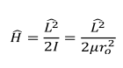

We can show the Hamiltonian operator as function of theta and .and then equate them to M and solve them individually. L=r X p this formula gives us an equation and when operated for the x and p operators gives us the angular momentum operator. When we operate the L operator on the phi function it gives an eigenvalue which is proportional to the m value, which shows it is quantized. As L is quantized the energy is also quantized

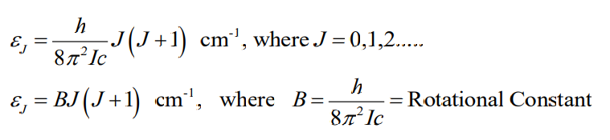

Hydrogen Atom:

The Schrodinger’s equation in hydrogen atom is represented as

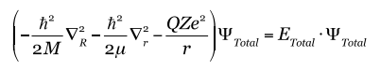

We can convert the following in to the relativistic equation and then we get the equation mentioned above. But in this equation, we have r which is in the x, y, z so it will be difficult to evaluate. Therefore, we again convert the equation in to the polar coordinates and finally we get the

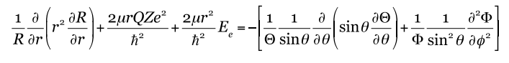

and I learn how to solve radial, theta and phi part differently.